CANDIDATE EXPERIENCE:
Navigate to the website or enter the following link to your browser address bar:
Visit website: www.wyfs.co.uk/careers/vacancies/
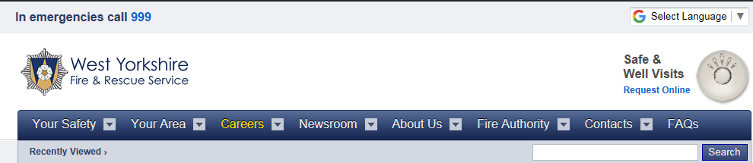
Click to apply for the position you are interested in
You will be re-directed to AccessRecruit.
The direct link for which is
https://isw.changeworknow.co.uk/west_yorkshire_fire_and_rescue_service/vms/e/careers/search/new
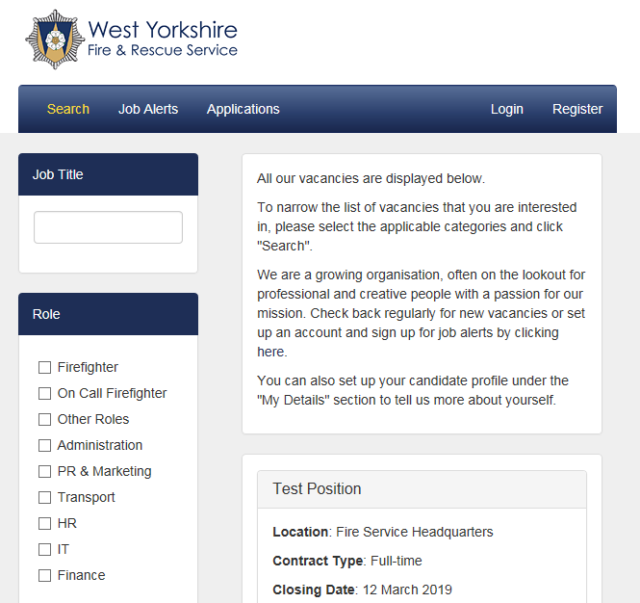

Click Register top right of page 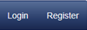
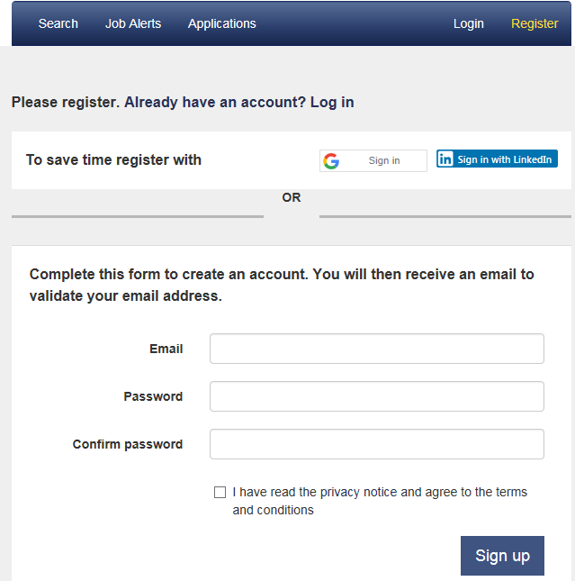
Complete all your details and tick the box for privacy notice and click Sign up
You will receive an email to validate your email address

This screen appears:
Validate account to activate
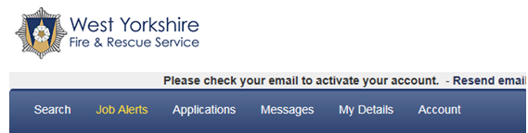
Name
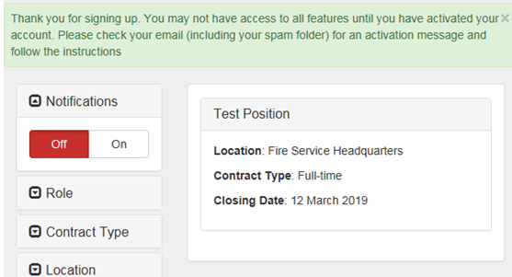

Validate your account by clicking on the email received click here see below:
Your email address will show here
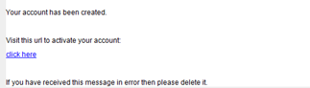

If you do not receive an email: Please double check your Spam/Junk mail folder in your email OR
Click Resend Activation email 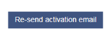
Name
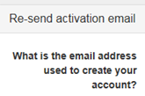Box with email address
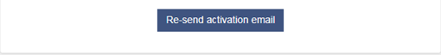

Once you have registered log into your account at the address below to apply for a position:
https://isw.changeworknow.co.uk/west_yorkshire_fire_and_rescue_service/vms/e/careers/search/new
Click on the Position to apply for: e.g. Test Position
Name
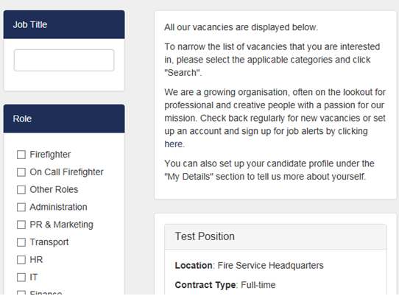

Click Apply Now
Name
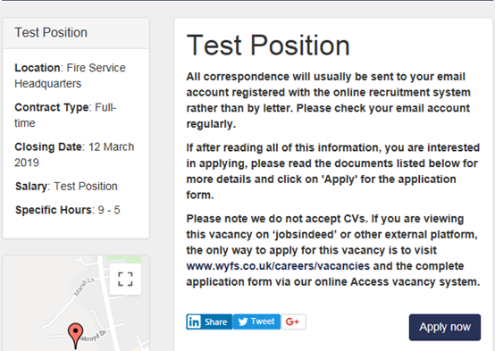

Information/Guidance about your application:
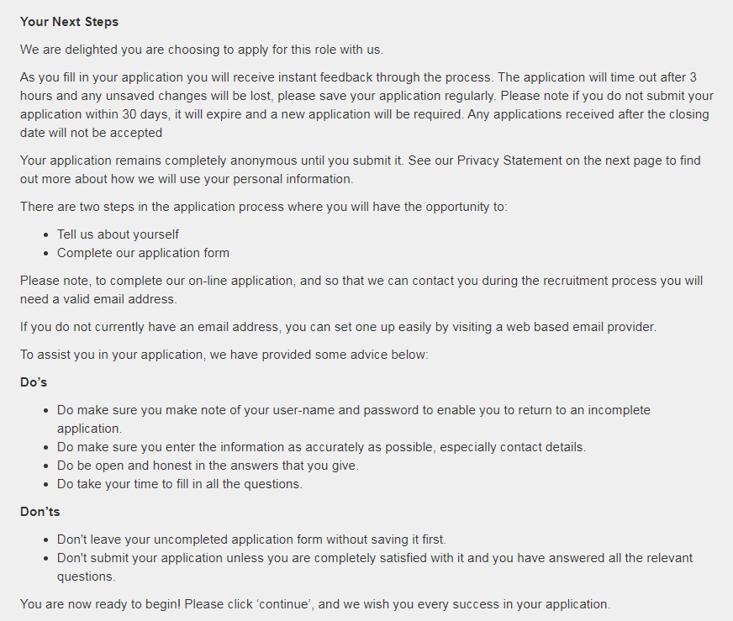
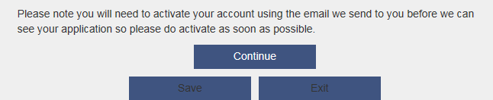

Click Continue

Data Protection and Personal Information:
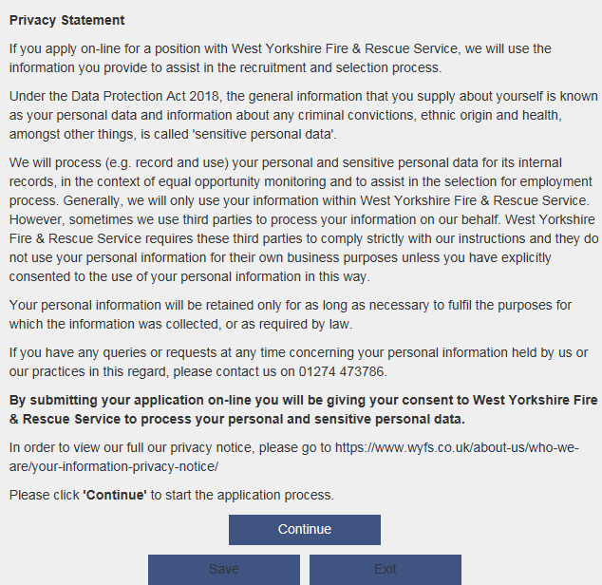
Click Continue

Complete Personal Details:
Name
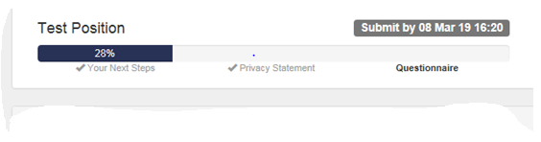
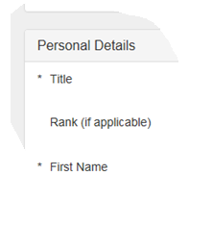
Click Continue at the bottom of each page, you can Save as you go along

Complete Work Experience:
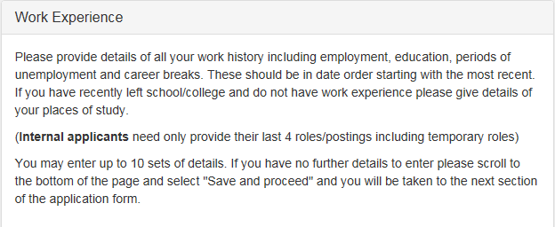
Click Continue at the bottom of each page, you can Save as you go along

Complete Qualifications:
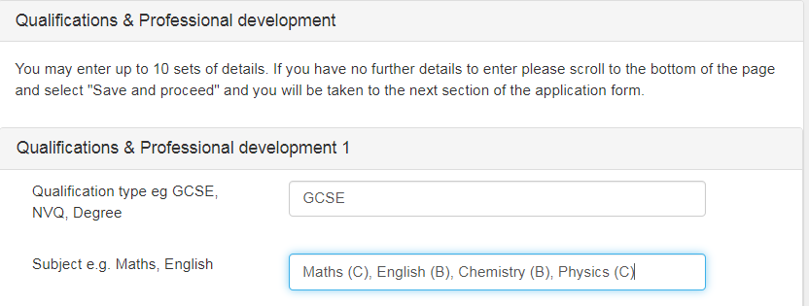
Click Continue at the bottom of each page, you can Save as you go along
(please note should you wish to return to this or any section to make amends before submitting your application, an opportunity is available in the ‘declaration’ section of the application to ‘modify answers’, as shown on page 14 of this guide).

Complete Supporting Statement:
Please note the application will time out after 3 hours, please save your application regularly. Candidates are advised to complete their supporting statement in Microsoft Word and then transfer the text into the supporting statement section of the application form.
To address the supporting statement please refer to Person Specification uploaded with the vacancy.
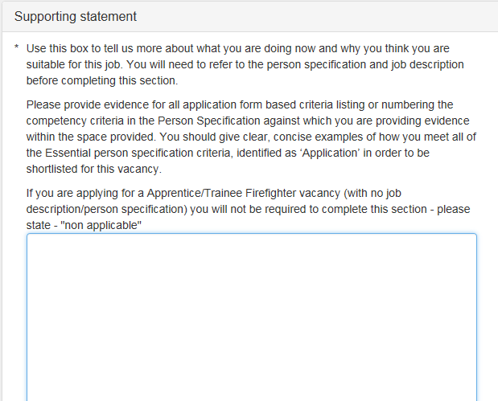

Complete References:
TIP: MUST COMPLETE TWO REFEREES WITH FULL DETAILS
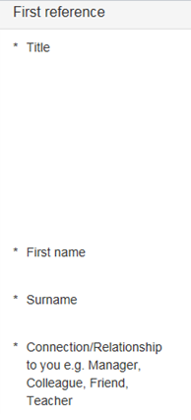
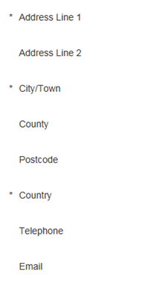
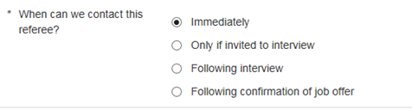
Complete Source of Application:
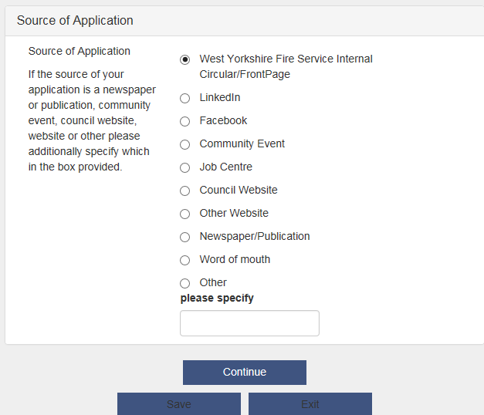

Complete Declaration
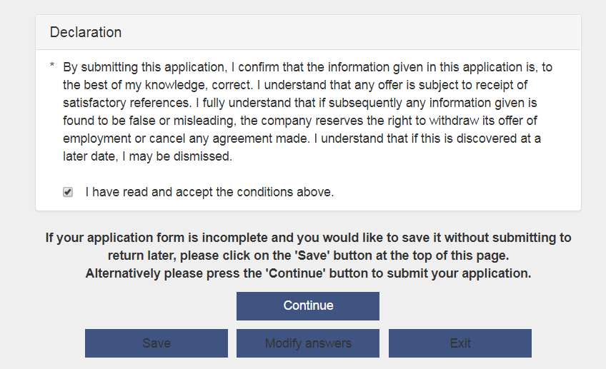

If your application is incomplete and you would like to save it without submitting to return later, please click on the button at the top of this page.
If you would like to go back and amend your answers and review your application before submitting please press
If your application is complete press to submit your application. Please note once you submit your application you will not be able to amend your application.

Complete Diversity Monitoring:
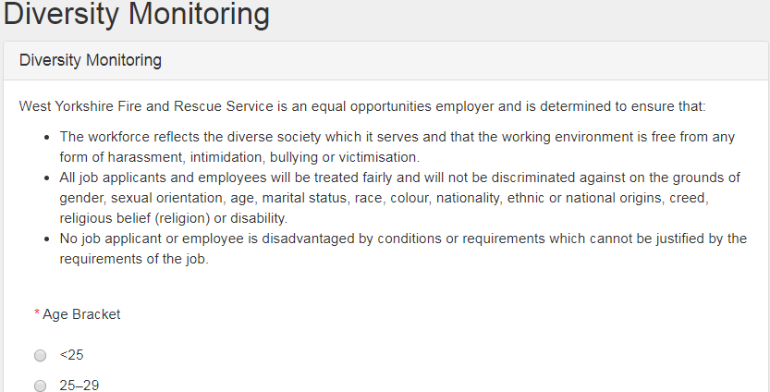

Click Save & Proceed 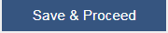

Complete Feedback:
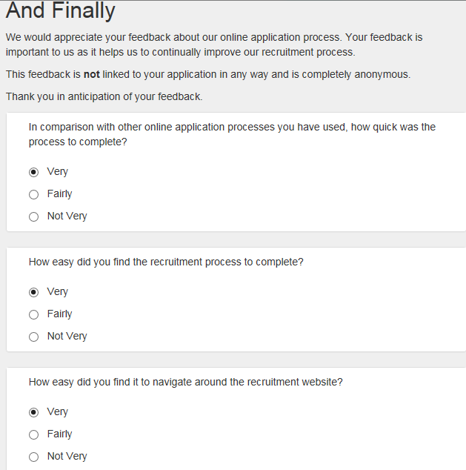
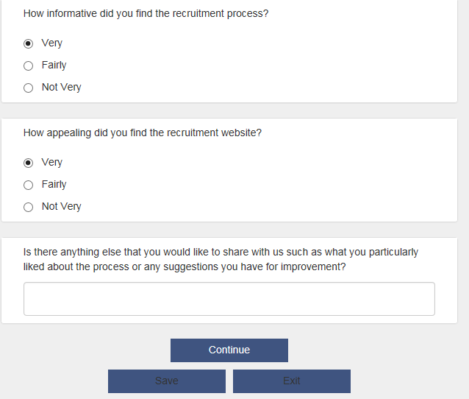
Click Continue at the bottom of each page, you can Save as you go along

This will take you back to your Current Applications screen:
Name
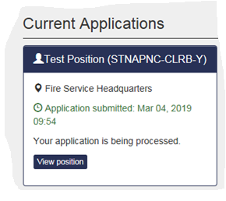
To review your application please click on the vacancy name as below
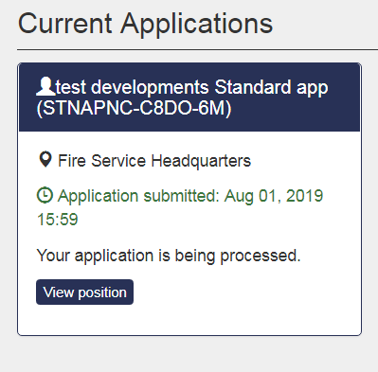
And Click on Review as below
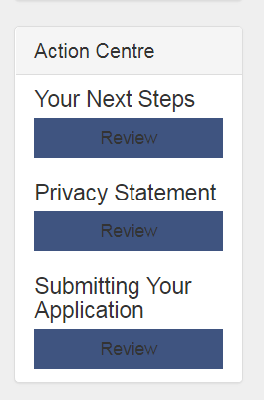
Which will bring up your submitted application
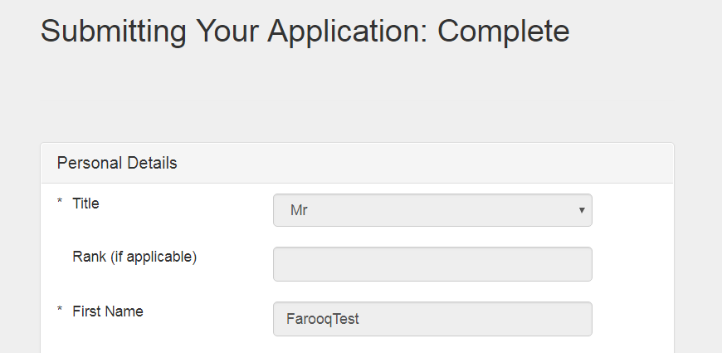
Always remember to Logout of account

General Recruitment System Navigation

Toolbar at the top of the screen has the following:
Search: allows you to search for vacancies
Job Alerts: will show current vacancies
Applications: will show current applications, each vacancy is in a box which will have a link which allows you to View Position or Click here e.g. You have been invited to book an appointment, just click on the link and select appointment slot for example. Previous applications are listed at the bottom of the page.
Messages: this allows you to click on the book an appointment. You can view Pending Messages.
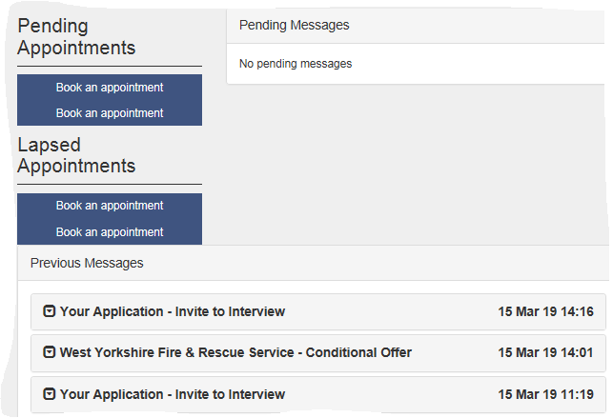
You can also look at Previous Messages by clicking on the drop down arrow at the side of the previous message, this will show you the full content of the email or message you were sent example below:
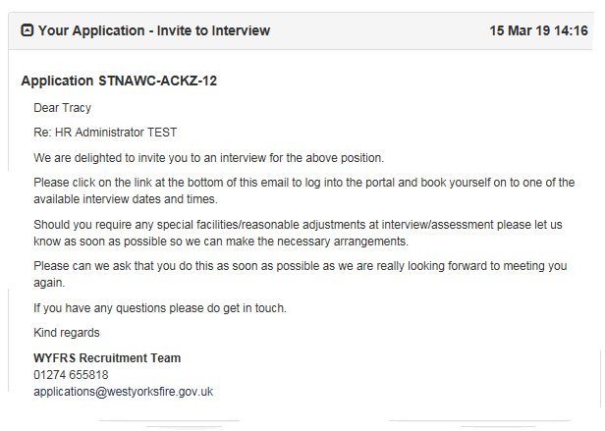
My Details: shows the personal details you have entered, these can be edited by clicking Edit Details in the relevant boxes. There is also a facility for you to add Notice Details, Curriculum Vitae (upload- however we do not accept CVs), Employment Details OR Education Details, these are not automatically populated from the application form, THESE NEED TO BE ADDED SEPARATELY.
TIP: You can also Edit your personal statement in this section.
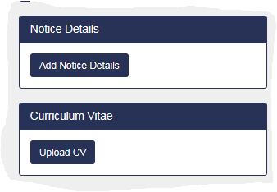
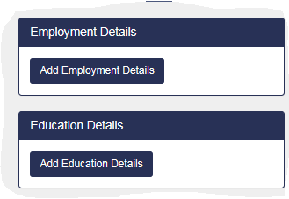
Account: In this section you can edit and change account details and delete account.
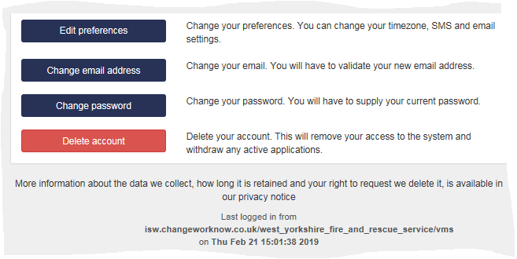
Logout: you can logout using the logout button on the right hand side

