WEST YORKSHIRE FIRE & RESCUE SERVICE.

JOB DESCRIPTION.

POST TITLE: | ICT Technician – IT Systems.
GRADE: | Grade 6.
RESPONSIBLE TO: | ICT Technical Support Manager.
PURPOSE OF POST: | To ensure that ICT Service delivery meets agreed KPI’s and positive Customer Experience is achieved. To maintain, install and configure IT equipment. To support Authority users in the use of ICT systems and services including technical support, user assistance and regular ongoing maintenance.
ORG CHART

MAIN DUTIES AND RESPONSIBILITIES OF THE ROLE.

- Uphold and successfully deliver the ICT Service Level Agreement within the Authority.
- Ensure that all requests for ICT support, services or resources are dealt with according to set, agreed and documented standards/procedures, ensuring compliance with ITIL processes.
- Delivery of positive ICT support activities in line with expected Customer Experience for the ICT Department, taking responsibility for ensuring consistent standards are maintained.
- To undertake the initial (and ongoing) configuration of ICT equipment purchased by the Authority; such as unpacking of equipment, checking deliveries against orders and configuring to required specification.
- To modify ICT equipment to encompass developments of existing or new equipment as used by the authority.
- Troubleshooting and resolution of issues in relation to ICT equipment, software and services.
- Work with technical support and infrastructure colleagues to modify ICT equipment to encompass developments of existing or new equipment as used by the Authority. Analyse and interpret data from various sources of complex fault information, utilising various data sources, log files, system monitoring tools or test equipment to find and rectify faults across ICT related equipment.
- Instructing users in the use of new hardware and software applications including communicating complex technical information at all levels including non-specialists.
- Maintain accurate records of Authority ICT equipment in line with asset management and configuration management activities.
- Work with end user departments and manage external contractors on installation, maintenance and warranty repair issues; exchanging complex technical information as required.
- Carry out routine maintenance & troubleshooting of ICT equipment at Fire Service locations. This may involve working in confined and/or awkward locations i.e. vehicles, equipment rooms and in small cramped spaces.
- Support the activities of the Technical Support team providing hands on assistance as/when required. This may for example involve supporting communications systems and mobile platforms/devices.
- Willingness to participate in the Authority standby scheme as required.
ORGANISATIONAL WIDE RESPONSBILITIES:

- Adherence to the Core Code which sets out five ethical principles, based on the Seven Principles of Public Life.
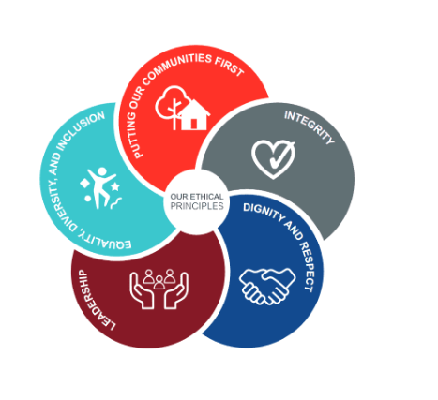

- To Implement and promote the Authority’s:
- Health and Safety policies.
- Equality and Diversity policies.
- Information Security Management System policies.
- Safeguarding policies.
- Business continuity policy and contingency arrangements.
- Policies related to General Data Protection Regulation and Data Protection Act 2018.
- Commitment to maintaining our Customer Service expectations.

SKILLS AND EXPERIENCE REQUIREMENTS FOR THIS ROLE.

 | Experience. | Essential/ Desirable. | Where Identified.
 | Significant demonstrable experience of fault diagnosis and repair with proven experience of installation and configuration of networked PCs and software. | Essential. | Application & Selection Process.
 | Experience of working with Service Desk systems including incident management, asset management processes and equipment maintenance | Essential. | Application & Selection Process.
 | Experience of Windows OS 7/8/10, Office 2010/2016 and other applications in a networked environment. | Essential. | Application & Selection Process.
 | Specific experience, knowledge and interest in some or all of the following areas: Windows Server 2008/2012/2016, Active Directory, LAN & WAN Networking technologies, Windows 7/8/10, Office 2010/2016, Exchange 2016, SharePoint 2010/2016. | Desirable. | Selection Process.
 | Experience of fault diagnosis and repair of mobile platforms/devices and communications equipment such as phones, radios and tablets. | Desirable. | Application & Selection Process.
 | Experience of working in the public sector – preferably a blue light service. | Desirable. | Application.

 | Education and Training. | Essential/ Desirable. | Where Identified.
 | Educated to NVQ level 3 in a computer related subject or have the equivalent relevant training and/or experience. | Essential. | Application.
 | ITIL Foundation certified or ability and willingness to undertake this qualification. | Essential. | Application.
 | Certification of appropriate professional technical qualification relating to ICT such as: Microsoft Windows Server, Windows Desktop OS, Virtual Environments or Networking Technologies or equivalent relevant experience. | Essential. | Application Form &  Selection Process.

 | Special Knowledge and Skills. | Essential/ Desirable. | Where Identified.
 | Ability to communicate at required levels with confidence and clarity taking account of audience. | Essential. | Application Form &  Selection Process.
 | Ability to work to tight deadlines, under pressure with effective time management skills. | Essential. | Application Form & Selection Process.
 | Excellent organisational skills with the ability to work with or without significant supervision when required. | Essential. | Application Form & Selection Process.
 | Demonstrate an understanding of the importance of equality and diversity to WYFRS as an employer and service provider. | Essential. | Selection Process Only.
 | To hold and maintain a current full valid car driving licence. | Essential. | Application.
Reviewed July 2018. Grade updated following pay assimilation Jan 2020. New Pay and Grade Scheme September 2022 Grade 6. Reviewed January 2024.

PERSON SPECIFICATION/SHORTLISTING CRITERIA.

In order to be shortlisted for the post you will need to demonstrate your ability to meet the requirements of the role by giving clear, concise examples of how you meet each of the person specification criteria on your application form. On your application form please list or number the competency criteria against which you are providing evidence/examples.

You will only be shortlisted from the details in the application form if you meet all Essential criteria, i.e. items you must be able to do from day one to be able to perform the role. If a large number of applications are received, only those who also meet the Desirable criteria will be shortlisted, i.e. criteria you need to undertake the role, but which could be learnt during training.

There may be some criteria that are identified through ‘Selection Process’ only. You will only be assessed on these criteria during the selection process and not from your application form, this may involve tests, presentations, interview etc.

