WEST YORKSHIRE FIRE & RESCUE SERVICE.

JOB DESCRIPTION.

POST TITLE: | Youth Intervention Trainer.
GRADE: | 5
RESPONSIBLE TO: | Youth Interventions and Prince’s Trust Manager.
PURPOSE OF POST: | To support the delivery and development of Youth Interventions, Prince’s Trust and other youth related projects and partnerships, aimed at promoting behaviour change to targeted groups of young people, across West Yorkshire.
ORG CHART
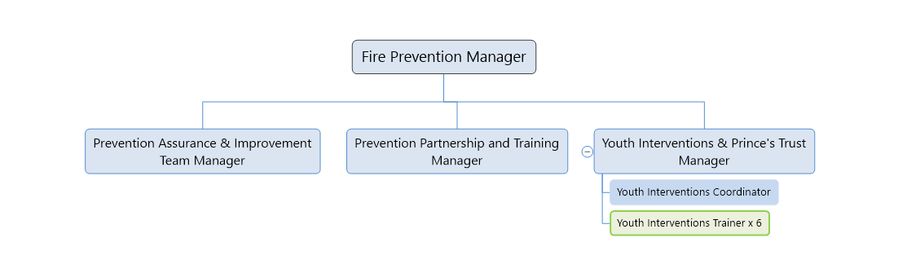

MAIN DUTIES AND RESPONSIBILITIES OF THE ROLE.

- Use expert knowledge of issues affecting young people to develop and deliver practical Youth Intervention and Prince’s Trust programmes that engage targeted groups and individuals from diverse and challenging backgrounds across West Yorkshire.

- Take a strategic West Yorkshire wide view to develop, implement and review multi-agency partnerships and initiatives to identify and address risk affecting communities and young people and West Yorkshire Fire and Rescue service.

- Ensure that accurate and comprehensive records relating to all activities are maintained and prepare reports to communicate the progress, achievements and giving recommendations where appropriate on issues arising to ensure that youth intervention work continues to be undertaken at maximum effectiveness.

- To support the Youth Intervention Training Team Manager in the progression of the Youth Interventions Team Strategy.

- Represent Youth Interventions and WYFRS at multi agency meetings as required.

- Actively promote and publicise of the work of the Youth Interventions team both internally and with external stakeholders, partners and agencies.

ORGANISATIONAL WIDE RESPONSBILITIES:

- Adherence to the Core Code which sets out five ethical principles, based on the Seven Principles of Public Life.
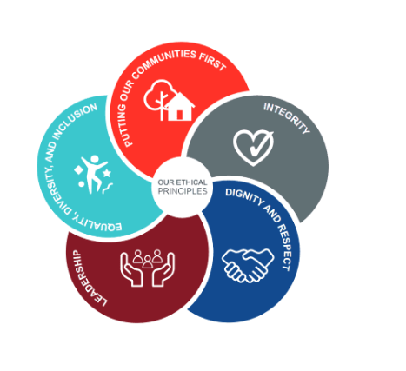

- To Implement and promote the Authority’s:
- Health and Safety policies.
- Equality and Diversity policies.
- Information Security Management System policies.
- Safeguarding policies.
- Business continuity policy and contingency arrangements.
- Policies related to General Data Protection Regulation and Data Protection Act 2018.
- Commitment to maintaining our Customer Service expectations.

SKILLS AND EXPERIENCE REQUIREMENTS FOR THIS ROLE.

In the supporting statement section of the application form give clear, concise examples of how you meet all of the Essential person specification criteria (i.e. items you must be able to do from day one to be able to do the job), identified as ‘Application’ in order to be shortlisted for this vacancy. If a large number of applications are received, only those who also meet the Desirable criteria, identified as ‘Application’, will be shortlisted, i.e. criteria you need to do the job, but which could be learnt during training.

Please list or number the competency criteria below against which you are providing evidence/examples in order to structure your supporting statement in a well organised way.

There may be some criteria that are identified through ‘Selection Process’ only. You will only be assessed on these criteria during the selection process and not from your application form, this may involve tests, presentations, interview etc.

 | Experience. | Essential/ Desirable. | Where Identified.
 | A track record of relating to and empowering hard to reach young people to turn their lives around, change behaviour and make positive choices through structured interventions. | Essential. | Application & Selection Process.
 | Experience of developing, delivering and promoting interactive learning experiences and programmes for young people from first concept to finished product. | Essential. | Application & Selection Process.
 | Ability to communicate effectively both in person and digitally with a wide range of audiences to build relationships, deliver learning outcomes and present information in a clear logical manner. | Essential. | Application & Selection Process.
 | Experienced success in the application of innovative thinking and problem solving to obtain effective outcomes for young people. | Desirable. | Selection Process.
 | Ability to be self motivated and prioritise work and projects to self-imposed and externally required deadlines with minimal supervision. | Essential | Application & Selection Process

 | Education and Training. | Essential/ Desirable. | Where Identified.
 | Good standard of education to A-level or equivalent Level 3 qualification with evidence of continuous professional development through formal or informal routes. | Essential. | Application.
 | A high standard of written and oral communication, and numerical skills. | Essential. | Application & Selection Process.
 | To hold, be working towards or be willing to work towards a recognised, level 3 or above, teaching qualification such as an Award in Education and Training (formerly PTLLS). | Essential. | Application & Selection Process.

 | Special Knowledge and Skills. | Essential/ Desirable. | Where Identified.
 | Have an in depth understanding of the social and environmental issues affecting young people including criminal activity, poverty, mental health issues, homelessness, drug and alcohol related issues backed with knowledge of relevant national and local government agendas. | Essential. | Application & Selection Process.
 | Demonstrate an understanding of Safeguarding Policy how to practically apply safeguarding legislation and policy to when working with children and young people. | Essential. | Application.
 | Knowledge and experience of using practical techniques for working with a range of behaviours presented by young people in both a proactive and reactive way. | Essential. | Selection Process.
 | Demonstrate an understanding of how to implement policies such as Health & Safety and Diversity and inclusion. | Essential. | Selection process.
 | To hold and maintain a current full valid driving licence and a willingness to be trained to legally drive brigade vehicles as required. | Essential. | Application.

JD: Reviewed May 2018. Updated January 2021. Updated February 2022. Updated January 2024.

