WEST YORKSHIRE FIRE & RESCUE SERVICE.

JOB DESCRIPTION.

POST TITLE: | Occupational Health & Safety Unit Administrator/ Receptionist.
GRADE: | Grade 2.
RESPONSIBLE TO: | Senior Occupational Health Nurse.
PURPOSE OF POST: | To provide comprehensive reception and administration support to the Occupational Health and Safety Unit.
ORGANISATIONAL CHART
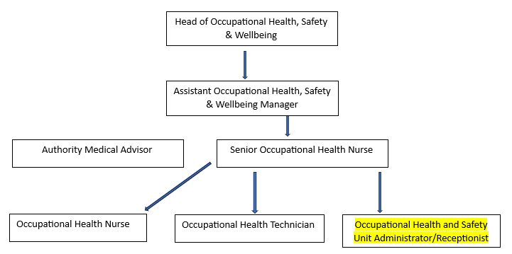

MAIN DUTIES AND RESPONSIBILITIES OF THE ROLE – See below for full details.

- Obtaining and maintaining documentation for colleagues’ medical records.
- Maintaining data and configuration of reports for the OHU IT system.
- Assisting clinical staff with clinics by producing and distributing medical reports appropriately.
- Perform and administer financial tasks for payment of goods and services.
- Provide reception and administration duties to help the smooth-running of the department.
- Miscellaneous duties.

ORGANISATIONAL WIDE RESPONSBILITIES:

- Adherence to the Core Code which sets out five ethical principles, based on the Seven Principles of Public Life.
.2. To Implement and promote the Authority’s:
- Health and Safety policies.
- Equality and Diversity policies.
- Information Security Management System policies.
- Safeguarding policies.
- Business continuity policy and contingency arrangements.
- Policies related to General Data Protection Regulation and Data Protection Act 2018 .
- Commitment to maintaining our Customer Service expectations.

SKILLS AND EXPERIENCE REQUIREMENTS FOR THIS ROLE.
In the supporting statement section of the application form give clear, concise examples of how you meet all of the Essential person specification criteria (i.e. items you must be able to do from day one to be able to do the job), identified as ‘Application’ in order to be shortlisted for this vacancy. If a large number of applications are received, only those who also meet the Desirable criteria, identified as ‘Application’, will be shortlisted, i.e. criteria you need to do the job, but which could be learnt during training.

Please list or number the competency criteria below against which you are providing evidence/examples in order to structure your supporting statement in a well organised way.

There may be some criteria that are identified through ‘Selection Process’ only. You will only be assessed on these criteria during the selection process and not from your application form, this may involve tests, presentations, interview etc.

 | Experience. | Essential/ Desirable. | Where Identified.
 | Demonstrate experience of providing varied administrative support (e.g. liaising with external organisations, maintaining accurate records, dealing with confidential information, financial duties). | Essential. | Application Form and Selection Process.
 | Proficient in the use of Microsoft Office applications (in particular Word, Outlook and Excel) and have good keyboard skills. | Essential. | Application Form and Selection Process.
 | Experience in the use of a medical IT system and/or other internal databases. | Desirable. | Application Form and Selection Process.

 | Education and Training. | Essential/ Desirable. | Where Identified.
 | Numeracy and Literacy skills either Level 2 qualifications or GCSE Maths and English Grade A to C or 4 to 9, or an equivalent level of literacy and numeracy gained through work experience. | Essential. | Application Form and Selection Process.

 | Special Knowledge and Skills. | Essential/ Desirable. | Where Identified.
 | Ability to maintain confidentiality (both verbal and written) regarding employee data. | Essential. | Application Form and Selection Process.
 | Excellent verbal and written communication skills with ability to communicate with a wide range of people. | Essential. | Application Form and Selection Process.
 | Excellent organisation skills and ability to work on own initiative, to prioritise workloads and meet deadlines. | Essential. | Application Form and Selection Process.
 | Ability to pay close attention to detail to ensure data and records are accurate and maintained to a high standard. | Essential. | Application Form and Selection Process.
 | Ability to work as part of a team. | Essential. | Application Form and Selection Process.
 | Demonstrate commitment to and understanding of Equality and Diversity. | Essential. | Application Form and Selection Process.

Tasks Include but not Limited to:

Maintaining Confidentiality. | Maintain the confidential medical information obtained by the department in all its forms (verbal or written) in line with medical ethical standards and GDPR.
Obtaining and preparing documentation. | Obtain and prepare the various types of documents needed to carryout the routine work of the Occupational Health Unit (OHU). Liase verbally and in writing with GP Practices, hospital departments, and private health care providers to obtain the appropriate appointments, information and documentation required to support the clinical team.  Prepare the necessary paperwork and records for various medical processes to be undertaken, including:  - Pre-employment assessments/medicals,  - Sickness absence reviews,  - Management referrals,  - Private referral,  - Pension assessments,  - Routine health screening/health surveillance.
IT Duties. | Maintain the OHU IT data base through inputting of data and configuration of the system for reporting purposes, to help maintain the department’s needs.  Format and produce the Authority Medical Advisor’s reports and letters; and distribute appropriately (according to informed consent) where necessary.  Access other internal data bases to run reports and provide information regarding sickness absence and modified duties so appropriate appointments can be generated.
Financial duties | Abide by the requirements of the procurement/finance processes in order to process the invoice/payment needs of the OHU department, including:  - Liasing with suppliers to obtain appropriate information required for them to be establisted on the finance system.  - Use the finance database to raise purchase order numbers and provide to suppliers.  - Authorise purchase orders and receipt invoices.  - Book training and make purchases using the department credit card.  - Liase with procurement/finance to deal with any queries etc.
General administration and reception duties. | Provide reception duties for people attending and telephoning the department.  Book appropriate dates and times for initial attendance and follow up appointments as required.  Scan and upload documents generated by and received within the department.  Liaise closely with other departments e.g. HR, Authority managers etc. regarding the outcomes of medicals and OHU consultations.  Provide first point of contact basic advice and information to answer general queries from all levels of staff, both over the phone and in person.  Deal with enquiries from internal and external customers via telephone, email, face to face and Teams.  Undertake administrative duties to support the function of the Occupational Health Unit including: producing statistics and reports, scanning, photocoping and inputting data; answering calls and taking messages.  Undertake general administrative duties for the Health and Safety department, when required.
Miscellaneous. | To Implement and promote the Authority’s policies including but not limited to:  Health and Safety policies,  Equality and Diversity policies,  Information Security Management System policies,  Safeguarding policies,  Business continuity policy and contingency arrangements.  To demonstrate and uphold the service values and to promote the organisation in a positive manner.  Ensure functions can be maintained when disruptive events occur through the implementation of arrangements specified in the business continuity strategy/policy.  Responsibility for ensuring any data produced in relation to the post is accurate and current.  Responsibility to ensure full compliance with the General Data Protection Regulation and Data Protection Act 2018 and to ensure data security is maintained.  Maintain up to date knowledge and skills through participation in training and development.  Undertake other appropriate duties as directed by the Occupational Health Team.

Job Description: Reviewed: 15/01/2024

