WEST YORKSHIRE FIRE & RESCUE SERVICE

JOB DESCRIPTION

POST TITLE: | Treasury Management Officer
GRADE: | Grade 9
RESPONSIBLE TO: | Head of Finance
PURPOSE OF POST: | The main purpose of this post is to manage the authority’s cash flow by the management of investments and deposits with financial institutions. This post is also responsible for the management of the provision of accurate, understandable and timely financial information and the preparation of the Authority’s financial accounts.  This post will act as deputy Head of Finance in their absence.

ORGANISATION CHART

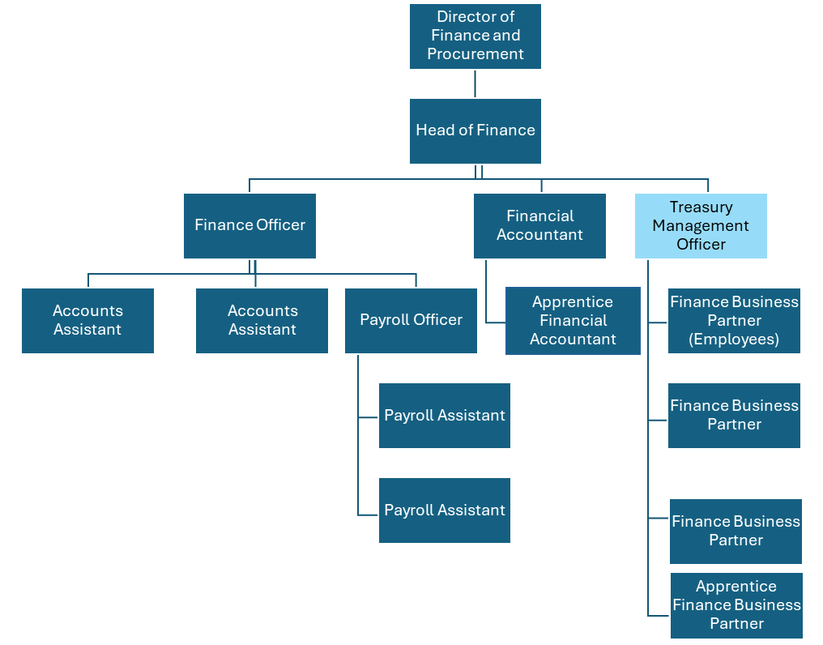

MAIN DUTIES AND RESPONSIBILITIES OF THE ROLE

- Treasury Management
- Management of the day to day cash balances including the arrangement of investments and loans in accordance with the Treasury Management Strategy and ensuring the best rates of interest are obtained.
- Liaison with the Authority’s Treasury Management advisors and financial brokers and day to day management of the banking relationship with Barclays Bank.
- Reconciliation of bank statements and control accounts.
- Preparation of the treasury management outturn and mid-year report for the Director of Finance and Procurement for presentation to Finance and Resources Committee.
- Preparation the treasury management strategy for the Director of Finance and Procurement for presentation to Full Authority for approval.
- Preparation of the monthly cash flow monitoring report.
- Calculation of capital financing charges budgets and maintenance of systems to enable the accurate monitoring of capital financing charges and the impact on the revenue budget of future capital programs.

- Financial Accounting
- To assist with the production of the Statement of Accounts and the co-ordination of the external audit including the production of key financial statements and supporting notes to the Statement of Accounts, ensuring that statutory deadlines are strictly adhered to.
- Ensure that changes to CIPFA accounting code of practice are incorporated into the working papers and financial statements and that the accounts are presented in accordance with statutory requirements.
- Assist the Financial Accountant in the management and provision of management information in respect of the Authority’s reserves.
- Lead and co-ordinate the completion of Statutory Returns including the Whole of Government Accounts within the statutory deadlines.
- Working under time pressured conditions to ensure adherence to strict deadlines for the themselves and the team.

- Management Accounting
- Oversee and co-ordinate the provision of budget monitoring information (Capital and Revenue) on a monthly basis ensuring that expenditure is correctly coded and that the information is in an easy to understand format.
- To lead on the development and maintenance of monitoring reports that enables the Authority to maintain budgetary control in liaison with the Head of Finance.
- Co-ordinate the preparation of the annual budget and ensure that the deadlines for completion are met by the Finance Business Partners.
- Provide training to managers on financial procedures and ensure the adherence to these.
- Co-ordinate the provision of financial information to support the HMICFR inspection programme

- Management of the Finance Team
- Oversee the delivery of finance team projects and initiatives.
- Deputise for the Head of Finance and carry out any other appropriate duties as assigned by the Director of Finance and Procurement.
- Ensure that all finance related matters are communicated, as appropriate, throughout the organisation.
- To represent the finance department at internal and external meetings and conferences.

ORGANISATIONAL WIDE RESPONSBILITIES:

- Adherence to the Core Code which sets out five ethical principles, based on the Seven Principles of Public Life.

- To Implement and promote the Authority’s:
- Health and Safety policies.
- Equality and Diversity policies.
- Information Security Management System policies.
- Safeguarding policies.
- Business continuity policy and contingency arrangements.
- Policies related to General Data Protection Regulation and Data Protection Act 2018 .
- Commitment to maintaining our Customer Service expectations.

SKILLS AND EXPERIENCE REQUIREMENTS FOR THIS ROLE.

In the supporting statement section of the application form give clear, concise examples of how you meet all of the Essential person specification criteria (i.e. items you must be able to do from day one to be able to do the job), identified as ‘Application’ in order to be shortlisted for this vacancy. If a large number of applications are received, only those who also meet the Desirable criteria, identified as ‘Application’, will be shortlisted, i.e. criteria you need to do the job, but which could be learnt during training.

Please list or number the competency criteria below against which you are providing evidence/examples in order to structure your supporting statement in a well organised way.

There may be some criteria that are identified through ‘Selection Process’ only. You will only be assessed on these criteria during the selection process and not from your application form, this may involve tests, presentations, interview etc.

 | Experience. | Essential/ Desirable. | Where Identified.
 | Extensive knowledge of financial procedures and systems relevant to a public sector organisation. | Essential | Application \ Selection Process
 | Preparation of detailed financial reports for committees, management board and budget holders. | Essential | Application \ Selection Process
 | Ability to understand and explain complex financial information to a range of audiences. | Essential | Application \ Selection Process
 | Experience of treasury management in a large organisation. | Essential | Application \ Selection Process
 | Development and improvement of financial systems. | Essential | Application \ Selection Process
 | Extensive experience of the production of the Statement of Accounts for a large organisation. | Essential | Application \ Selection Process

 | Education and Training. | Essential/ Desirable | Where Identified.
 | Qualified CCAB accountant or equivalent. | Essential | Application
 | Evidence of continuing professional and personal development including current membership of a professional accounting body. | Essential | Application

 | Special Knowledge and Skills. | Essential/ Desirable. | Where Identified.
 | Extensive knowledge of accounting codes of practice, accounting conventions and accounting standards and experience in their application. | Essential | Selection Process
 | Appreciation of the current issues that are affecting the fire service and local government in general and a good understanding of how these issues affect the provision of financial management within the fire service. | Desirable | Selection Process
 | Excellent communication, presentation and people skills at all levels within the organisation. | Essential | Application \ Selection Process
 | Ability to prioritise own work and the work of others. | Essential | Selection Process
 | Ability to deal with conflicting priorities. | Essential | Application \ Selection Process
 | Ability to translate complex financial information and explain the results to non-financially trained managers. | Essential | Application \ Selection Process
 | Excellent IT skills to enable the preparation of complex financial reports. | Essential | Application \ Selection Process
 | Well developed analytical and problem solving skills. | Essential | Application \ Selection Process
 | Ability to develop the financial expertise of service managers. | Essential | Application \ Selection Process
 | An understanding of the democratic processes of policy within local government. | Desirable | Selection Process
 | Ability to plan, manage and implement projects. | Essential | Selection Process

Job Description: Last updated: 01/07/24

